KIDS ON THE GREEN

Questions
Are Parks of Toronto are ideally located with accessibility to schools with a medium to high population who have an After Care Program?
Based on population density Which school districts would be best served by the green space locations?
Based on location, will schools need to assess their After Care Traditional Program to incorporate Parks services , examples waterways etc?
Are both elementary and secondary schools both proportionately located to Parks, this will affect whether age groups will have better access to parks.

Introduction/ Business Problem
As one of the leading developed countries in the world, Canada facing mounting pressures in maintaining a healthy population. The issue of obesity among children has always been a concern within the public health and public safety sphere.
International Context
UNICEF’s global report, Report Card 12:Building the Future(2017), revealed that Canada ranked 25th out of 41 rich nations when it comes to child well-being. The report gauged Canada’s progress against 21 indicators related to progress towards the global Sustainable Development Goals for children and youth. Overall, Canada retained its middle placement , which it has held for at least a decade. In terms of physical health,the report highlighted that Canada ranked 29th of 41 countries when it comes to unhealthy weight of children. Nearly 25 per cent of young people are obese, above the average of 15 per cent.
The Government of Canada through the Pan-Canadian Public Health Network has articulated the through the “Towards A Healthier Canada” health promotion initiative there are important efforts are underway to help make social and physical environments where children live, learn and play more supportive of physical activity and healthy eating.
Childhood obesity has both immediate and long-term negative health outcomes, and is strongly linked to various chronic conditions, including type 2 diabetes, heart disease, and certain types of cancer.
- Almost 1 in 3 children and youth are overweight or obese
- 18.6% are overweight and 12.5% are obese.

Further analysis has been conducted to highlight the health disparities among Canadian Provinces based on rate for obesity. Figure 1 illustrates the percentage of the population with a body mass index of 30 or higher. The Province of Ontario has determined that increased attention is needed to address this as its rate of obesity is equal to the national rate of 18.4%
Figure 1: Map showing the percentage of the Canadian Population by Province body mass index of 30 or higher (obesity rate) 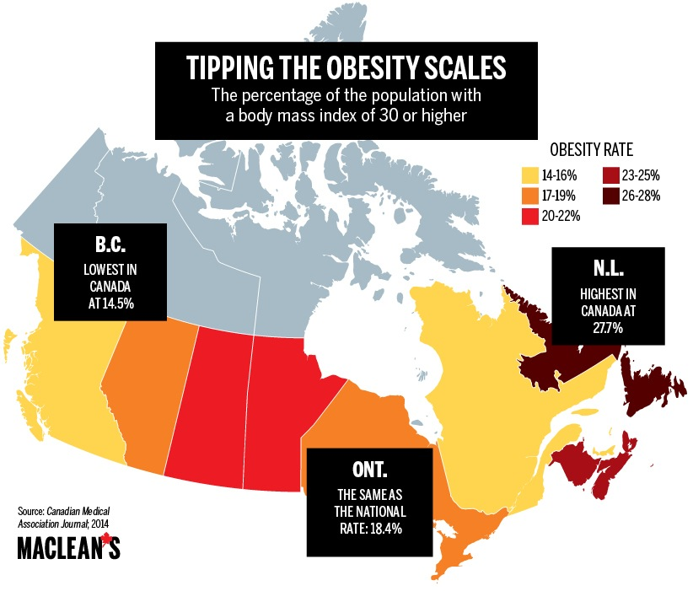

Ontario Focus
These findings have corroborated what the Ontario Collaborative Group for Healthy Eating and Physical Activity (OCGHEPA) has been advocating for. The OCGHEPA is a provincial collaboration of health professionals from organizations dedicated to addressing population-based issues related to healthy eating and physical activity. The OCGHEPA calls for Ontario to make healthy eating and being physically active easy and accessible for all. Funding for health promotion to support healthy eating, physical activity and a comprehensive chronic disease prevention strategy is lacking.

With specific focus on children, Figure 2 highlights the obesity statistics for children within Toronto.
Figure 2: Obesity Statistics for Children living in Ontario
90 % of children & youth do not meet daily physical activity guidelines
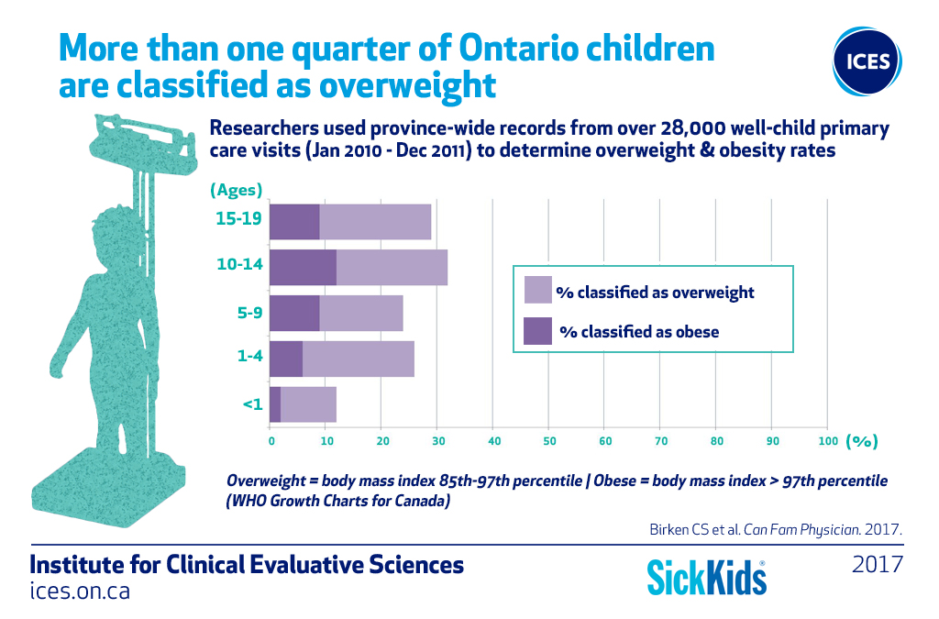

Solution
One primary solution articulated by Ontario Collaborative Group for Healthy Eating and Physical Activity (OCGHEPA) “is to create environments that support healthy eating and physical activity behaviours through a coordinated approach involving all relevant ministries and stakeholders and to invest in policies that help improve both healthy eating and physical activity in Ontarians in order to reduce chronic disease and health care spending” (OCGHEPA, 2018).

The OCGHEPA has been bequeathed a substantial grant from a benefactor, that must be utilized to incorporate 3 of the OCGHEPA Standing Recommendations:
- To increase access to quality recreation and sport opportunities for all Ontarians.
- To increase access for children to have quality after care programs in their community.
- To increase food literacy programs in child care programs, in school across all grade levels, and provide public health and community based food literacy programs

The OCGHEPA decided to establish a multi- sector approach green project with the pilot project with the intended beneficiaries : Children inclusive of school attending individuals up to 17 years old. The Steering Committee for OCGHEPA is to review the proposal “ Kids on the Green” location model for its viability in determining the best fit location .
The objective is to identify suitable and adequate green space (parks) operated by the Toronto Parks and Recreation Services which will collaborate with schools in its environs currently operating an After School Programme. The green space must be suited within Toronto it is the most populous city in Canada (and the most densely populated area in the Ontario province.

